Uncovering the Drivers of YouTube Trending Success
Armin Abbasi Najarzadeh
apmnh.armin@gmail.com
Abstract
This report delivers a comprehensive, data-driven exploration of the United States' YouTube Trending Video dataset, revealing the complex dynamics behind what propels content to trend and engage audiences. Through statistical analysis, machine learning modeling, and exploratory data visualization, it is uncovered how content category, upload timing, audience sentiment, and creator strategy shape a video’s trajectory on the platform. Key findings highlight the dominance of Music and Gaming in both reach and engagement, while prime-time uploads—especially around 7 PM—yield significantly higher interaction. The study confirms that controversial content, despite visibility, dampens engagement, and that viewer response is influenced by elements as granular as title length, description sentiment, and tag volume. A series of statistical tests reinforce these observations: videos published on weekends are far less likely to trend, while those with positive sentiment and non-clickbait titles enjoy measurably higher engagement scores. Predictive modeling with XGBoost identifies content category as the most influential feature in forecasting engagement. These insights culminate in a set of actionable recommendations aimed at optimizing content strategy, timing, and tone—empowering creators and analysts to make data-informed decisions in a fast-moving digital environment
Keywords: YouTube Trending, Viewer Engagement, Content Performance, Sentiment Analysis, Clickbait Detection, Upload Timing, Digital Content Strategy, Audience Perception, Creator Recommendations
1 Introduction
In the ever-evolving digital landscape, YouTube has emerged not just as a platform for video content, but as a cultural pulse point—where trends ignite, creators rise, and audiences engage in real time. Understanding what makes a video trend on YouTube goes far beyond raw view counts; it demands a multidimensional analysis of content type, timing, sentiment, audience behavior, and platform dynamics.
This report presents a deep dive into the United States’ Trending YouTube Videos dataset, capturing patterns that explain not only what rises to the top—but why. While global trends offer one perspective, analyzing region-specific data, like the U.S. subset, allows us to unearth insights shaped by local preferences, cultural context, and regional viewing habits. It’s in this granularity that real strategic value emerges—for creators, marketers, and analysts alike.
By combining exploratory data analysis, statistical testing, and predictive modeling, the mechanics of virality and viewer engagement are mapped out. From the outsized impact of upload timing to the subtle influence of title length and sentiment, each chapter builds toward a clearer picture of what fuels success on the platform
2 Dataset
The Trending YouTube Video Statistics [1] captures a detailed, day-by-day snapshot of the top trending YouTube videos across multiple countries. Sourced via the YouTube API, it includes millions of data points from 11 regions: the United States (US), Great Britain (GB), Germany (DE), Canada (CA), France (FR), Russia (RU), Mexico (MX), South Korea (KR), Japan (JP), and India (IN). For each country, up to 200 videos per day are listed, along with rich metadata such as video title, channel name, publish time, tags, view count, likes, dislikes, comment count, category, etc.
Each region's data is stored in a separate file, acknowledging the importance of localized analysis. In addition, category metadata is region-specific and provided in accompanying JSON files.
Why Analyzing Each Region Separately Is The Right Idea!?
Although tempting, analyzing the global dataset as a single entity obscures the nuanced dynamics of regional trends. YouTube engagement is deeply shaped by cultural context, viewing habits, time zones, and even language.
For example:
- Content categories and their popularity vary widely. Music might dominate in one country, while gaming or political content leads in another.

- Upload timing and user behavior differ—what performs well at 7 PM in the US might miss peak hours elsewhere.

- Engagement patterns, such as likes-to-views ratios or sentiment in descriptions, often reflect local preferences and social norms.

- The YouTube algorithm itself likely adapts to regional metrics when surfacing trending content.

By analyzing datasets for individual countries—such as the United States trending data—we ensure that insights are accurate, actionable, and culturally grounded. This granular approach allows for meaningful conclusions that might otherwise be lost in global averages, ultimately providing clearer direction for content strategy, platform research, and audience analysis.

2 Exploratory Landscape: Distribution, Dominance, and the Pulse of Popularity
2.1 Distributions: Viral Peaks & Consistent Baselines
Let's begin by examining the distribution of views, likes, and dislikes across trending videos. The patterns tell a familiar but important story:

Views cluster around a moderate range. While every video on the trending list earns a respectable reach, only a small handful break through into viral territory, soaring far beyond the median.

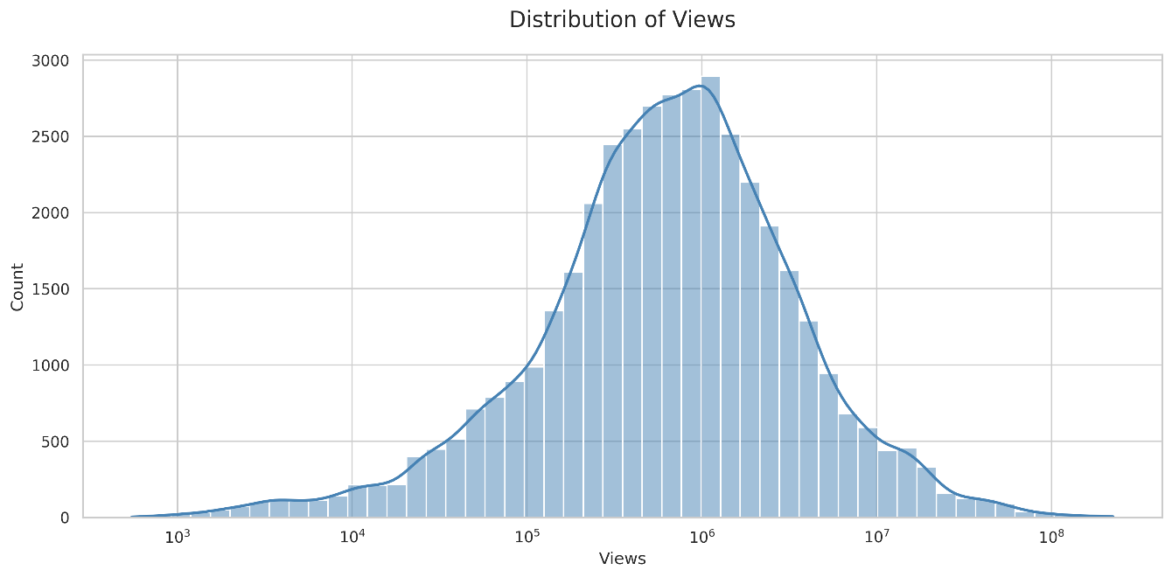

Likes skew heavily right: a few standout videos collect disproportionately high approval, creating a long tail of exceptionally liked content.

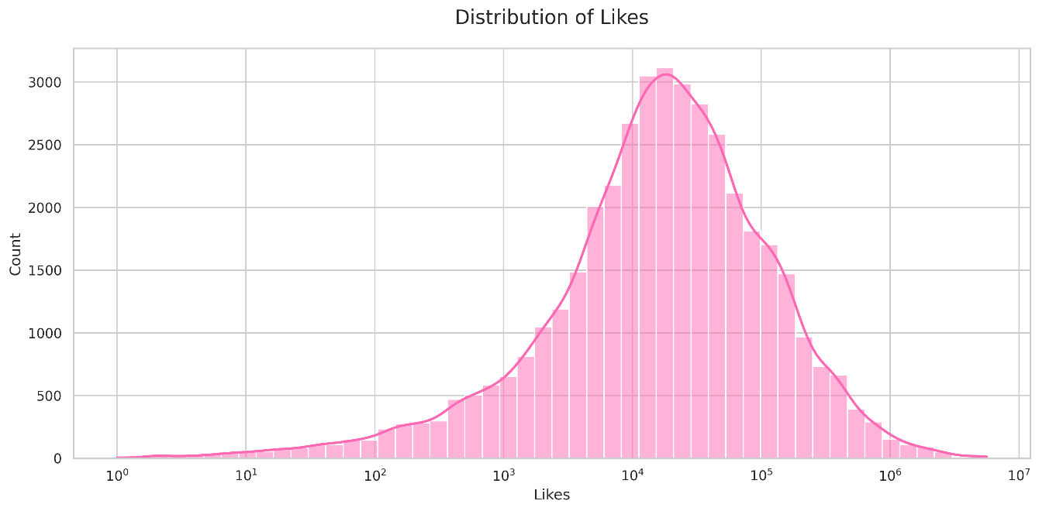

Dislikes are generally low. Most trending videos avoid significant negativity, though a minority of polarizing content registers noticeable spikes, hinting at controversy or divisive subject matter.

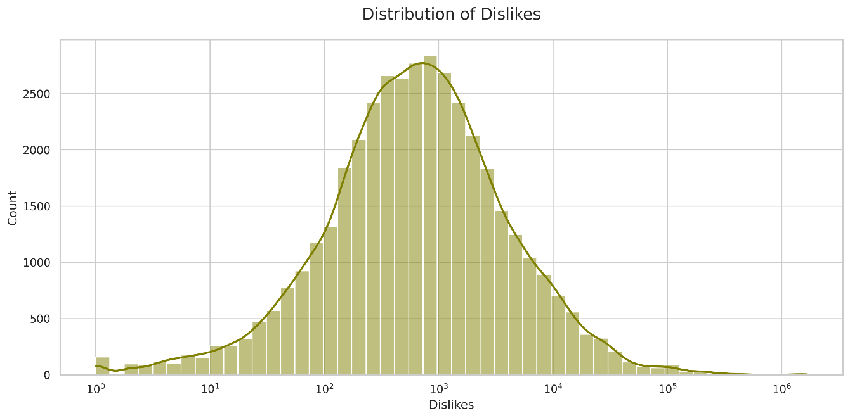

While most videos fall within a comfort zone of reach and approval, a few breakthrough hits climb far above the rest—and rare controversies register on the dislike radar.
Category Performance: Music’s Might & Gaming’s Consistency
When comparing category-level performance, two lenses offer contrasting insights: raw totals vs. median metrics.
- In total views, likes, and even dislikes, Music dominates—underscoring its broad appeal and passionate, vocal audiences.

- But when switching to medians, Gaming quietly takes the crown for views and dislikes, and ties closely with Music for likes—highlighting the reliable engagement of its tight-knit communities.
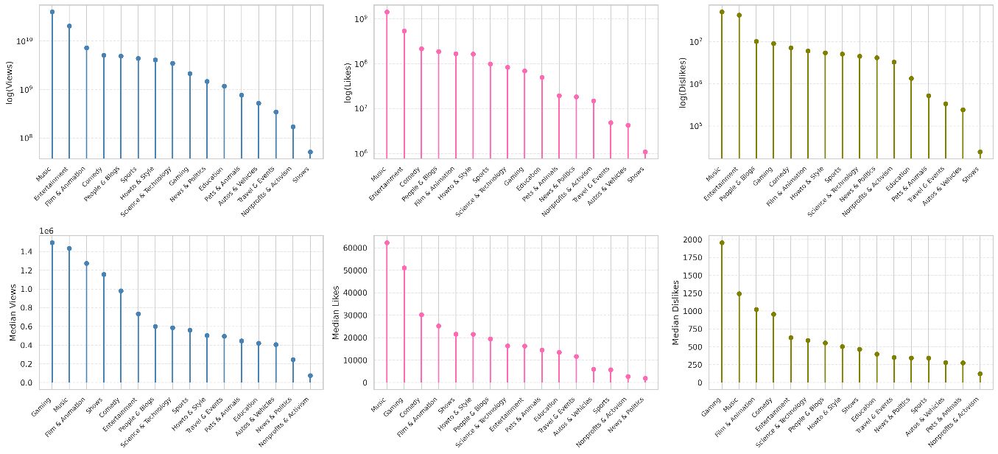
Meanwhile, Entertainment leads in total number of trending uploads, reflecting both the volume of content created and YouTube’s curation preferences.

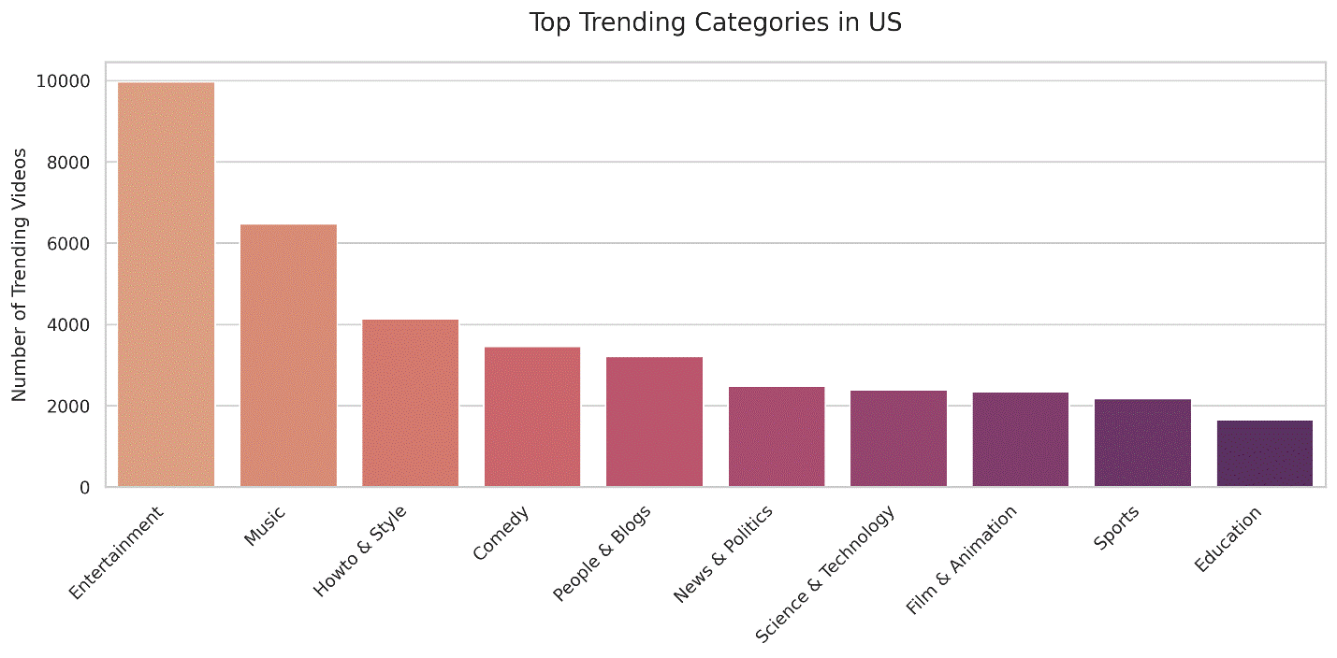
Brand Power: Who Rises to the Top?
Looking at top performers across the board, certain names recur with remarkable consistency:

- ESPN, late-night staples like Jimmy Fallon, Ellen, Colbert, Kimmel, Meyers, as well as Vox, Netflix, Screen Junkies, and the NBA, are all well-represented on the trending charts.

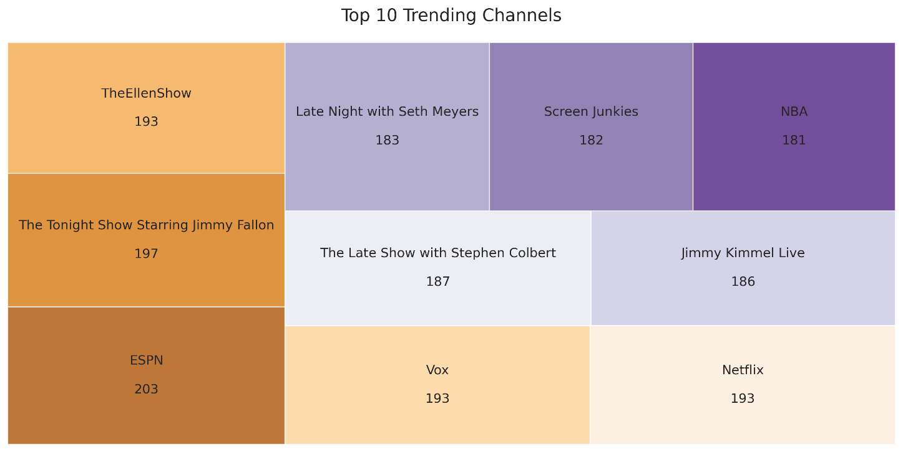
These creators share something in common: established brand equity and institutional momentum. They benefit from existing fan bases and distribution infrastructure that virtually guarantees exposure—raising the bar for independent or emerging creators aiming to compete.

Insight:
" Spotlight, Scale, and Staying Power."

This exploratory analysis reveals a layered landscape:

- Most trending videos cluster within a norm, but viral hits and controversies occasionally break the mold.

- Music and Gaming dominate—one in raw totals, the other in consistency and median strength.

- Legacy brands and major media personalities wield significant influence, shaping the trending charts through scale and recognition.

In a space that rewards both innovation and familiarity, understanding the baseline metrics and breakout anomalies is crucial for interpreting deeper patterns and planning strategic content decisions.

2.2 Timing Is Everything
Contrary to what some might expect, statistical testing reveals that the day of the week on which a video is uploaded does not significantly impact engagement. Viewer interaction appears to be remarkably consistent across weekdays and weekends. Whether a video goes live on a Monday or a Friday, its average ability to engage viewers—likes, dislikes, comments, and overall interaction—remains largely the same. This insight gives creators flexibility: when it comes to the day, consistency and content quality outweigh calendar concerns. However, this heavily depends on the goal of the content creator, as it only captures the engagement score of viewers as a whole regardless of them already being the core audience of the creator or not, if the creator wishes to expand their reach, then they have to optimize for trending, whose relationship to publish day is more nuanced, which will be addressed in section 4.
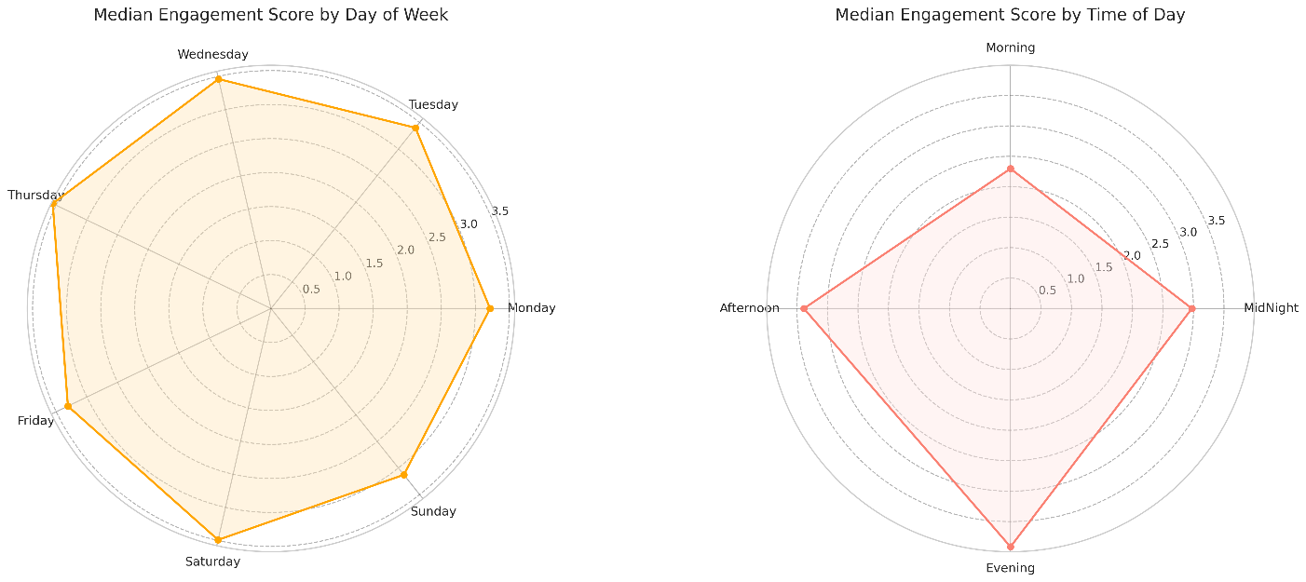
In sharp contrast, uploading at the right time of day significantly affects engagement. Analysis of the data shows a clear pattern: Engagement is lowest in the early morning hours (12 AM–10 AM), with a particular slump in the mid-morning window. From 10 AM to 4 PM, engagement begins to steadily rise, as user activity picks up.
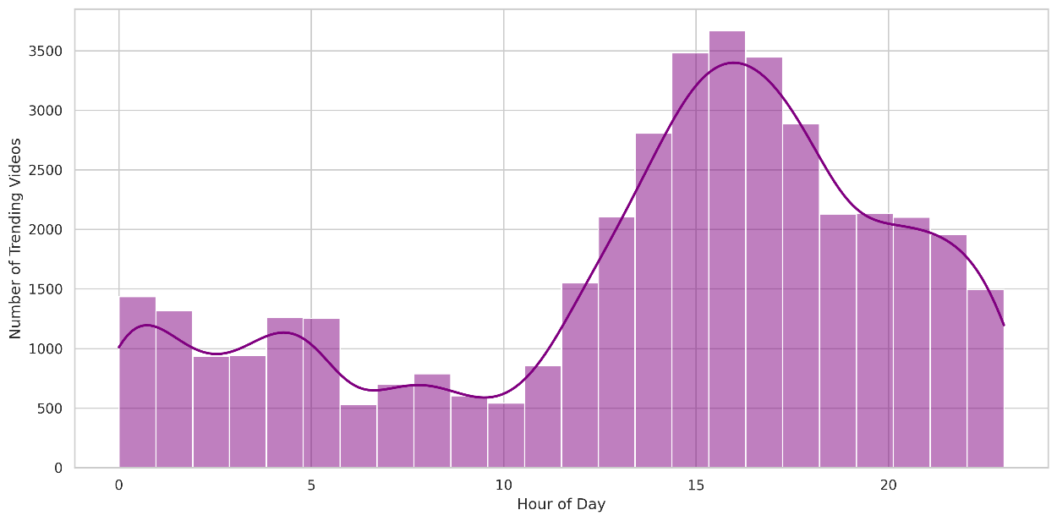

The peak engagement window lies in the evening—around 7 PM— coinciding with prime-time viewing hours when users are most active and receptive. A smaller but notable spike at 5 AM hints at an early-bird viewer segment, likely driven by specific niches or global time zone overlap.

Supporting this behavioral rhythm, upload patterns show a clear inverse correlation:

- Uploads are least frequent overnight (12 AM–10 AM)—when engagement is low.

- They increase steadily through late morning and afternoon (10 AM–4 PM)—as both creator activity and audience visibility improve.

- After 4 PM, uploads begin to taper off, although viewer engagement continues to rise until its 7 PM peak.
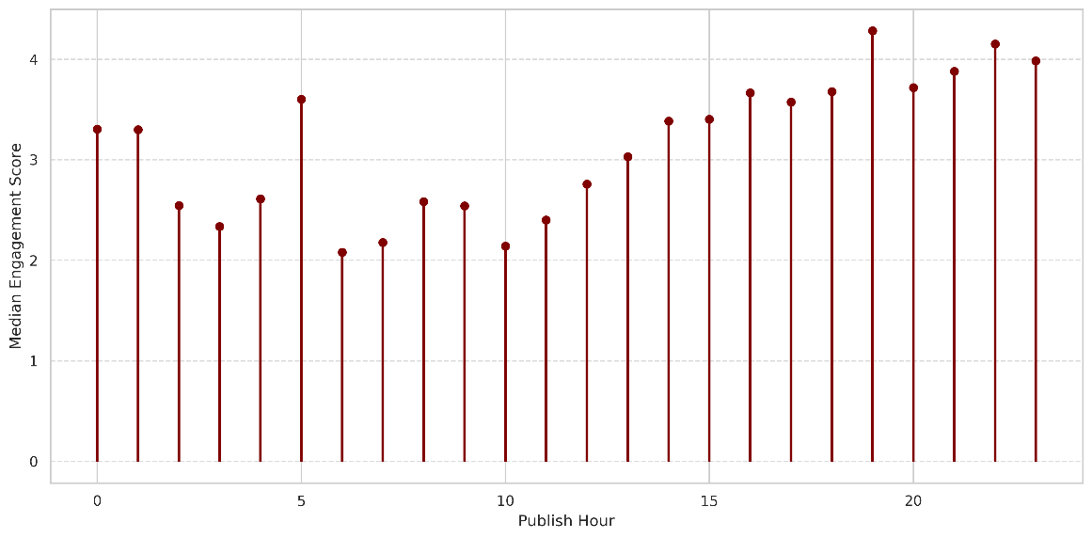
Insight:
"Time Is a Competitive Advantage."

The takeaway is simple but powerful: in capturing engagement, upload time matters more than upload day. Evening uploads—especially those landing between 5 PM and 8 PM—are far more likely to capture engaged audiences. Conversely, uploading in the early morning risks burying content beneath the algorithmic churn by the time viewers are active.
For creators aiming to optimize viewer interaction, scheduling uploads in the late afternoon to early evening window provides a strategic edge. It aligns with natural user habits—and in a crowded content landscape, timing just might be the most underrated growth tool.

2.3 Controversy and Clicks: How Viewer Sentiment Shapes YouTube Engagement
Do Controversial Videos Drive Engagement or Repel It?
To measure the emotional reception of a video, we analyzed the dislike-to-like ratio alongside an overall engagement score (factoring in likes, dislikes, and comments). The results are striking:

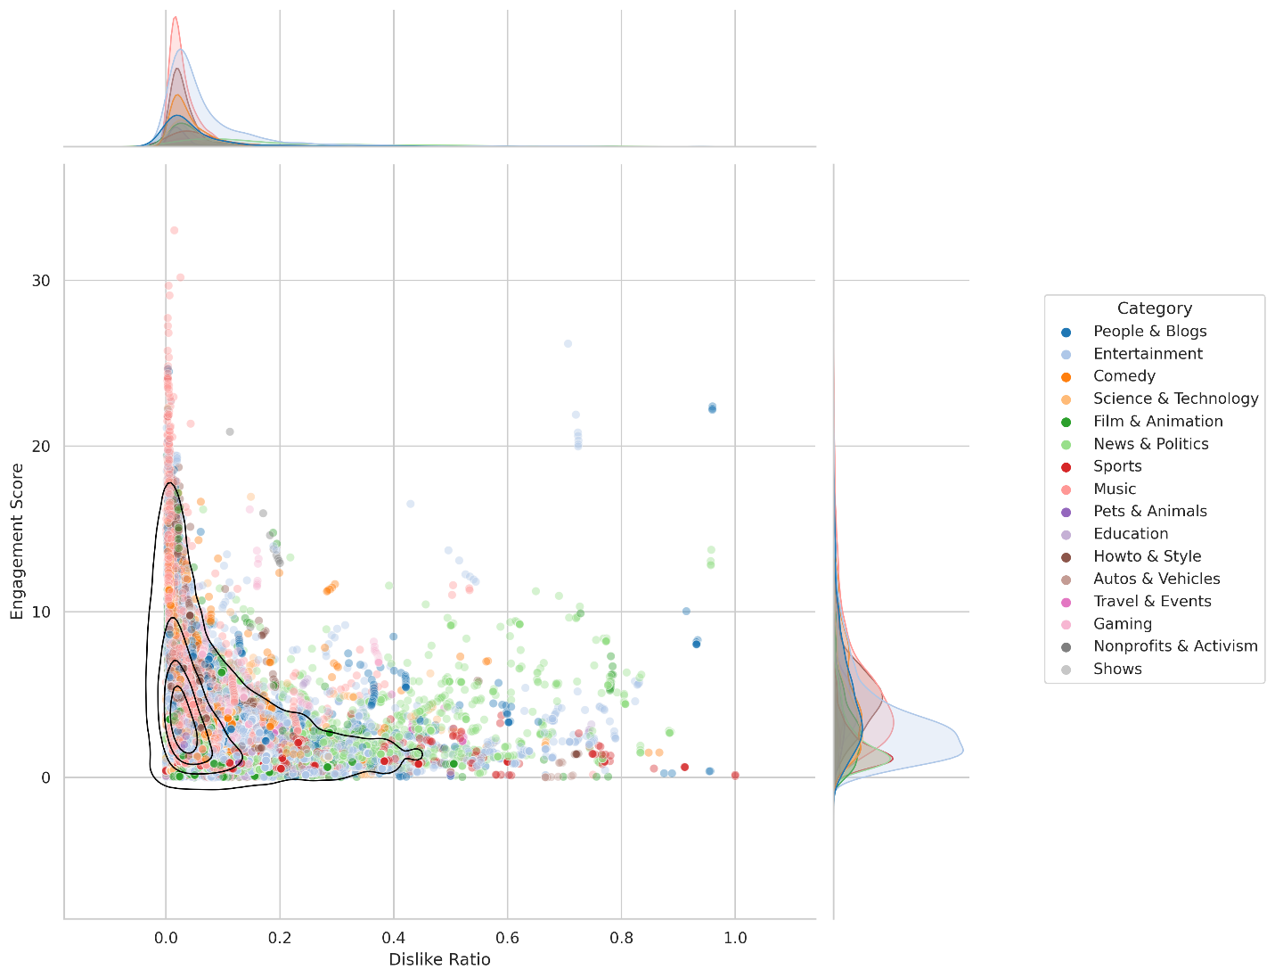
There is a strong inverse relationship between a video’s dislike ratio and its engagement score.
In other words, the more dislikes a video accumulates relative to likes, the lower its overall engagement. While such videos may still attract views—often driven by outrage, controversy, or polarizing opinions—they fail to foster positive, sustained interaction from the audience.
This pattern confirms a key distinction between visibility and connection. A video may trend for being provocative, but that doesn’t translate to community or loyalty.
Which Content Sparks the Most Disapproval?
When dislike ratios are broken down by category, a clear outlier emerges:
News & Politics videos have the highest median dislike ratio by a wide margin.
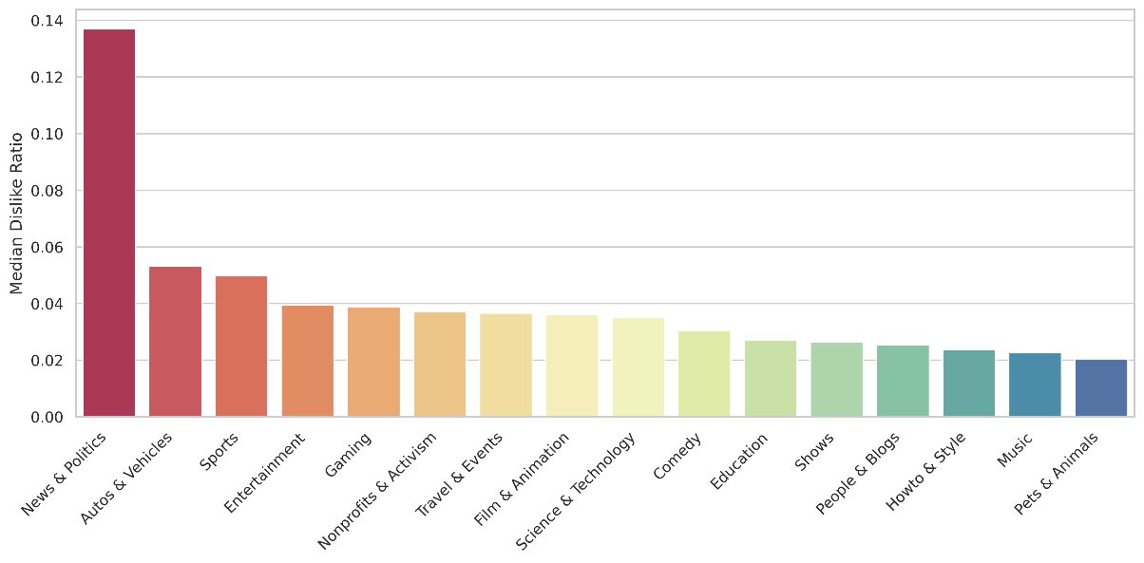
This finding aligns with broader platform dynamics—where content dealing with political commentary, current events, or ideological debates frequently sparks division and discontent. Although these videos often generate significant reach, they tend to evoke more criticism than support.
In contrast, categories like Music, Comedy, and Howto & Style consistently show lower dislike ratios and stronger overall engagement, suggesting that entertainment and utility-based content resonate more positively with viewers.

Insight:
"Engagement Is Not Just About Attention—It’s About Affinity."
This analysis highlights an important reality for content creators: going viral through controversy may bring eyes, but not loyalty. High dislike ratios act as a red flag, signaling disconnect between creator intent and audience expectations.

Creators and brands aiming for sustainable growth should focus on content that builds trust, delivers value, and invites interaction—not just reaction. In the long run, positive sentiment and constructive engagement are what turn casual viewers into committed communities.

2.4 The Metadata Effect: How Titles, Tags, and Descriptions Influence Viewer Engagement
What Do Trending Videos Tag Most? NEWS FLASH! Humor Takes The Throne.
“funny” and “comedy” are by far the most frequently used tags, outpacing all other keywords by a wide margin.
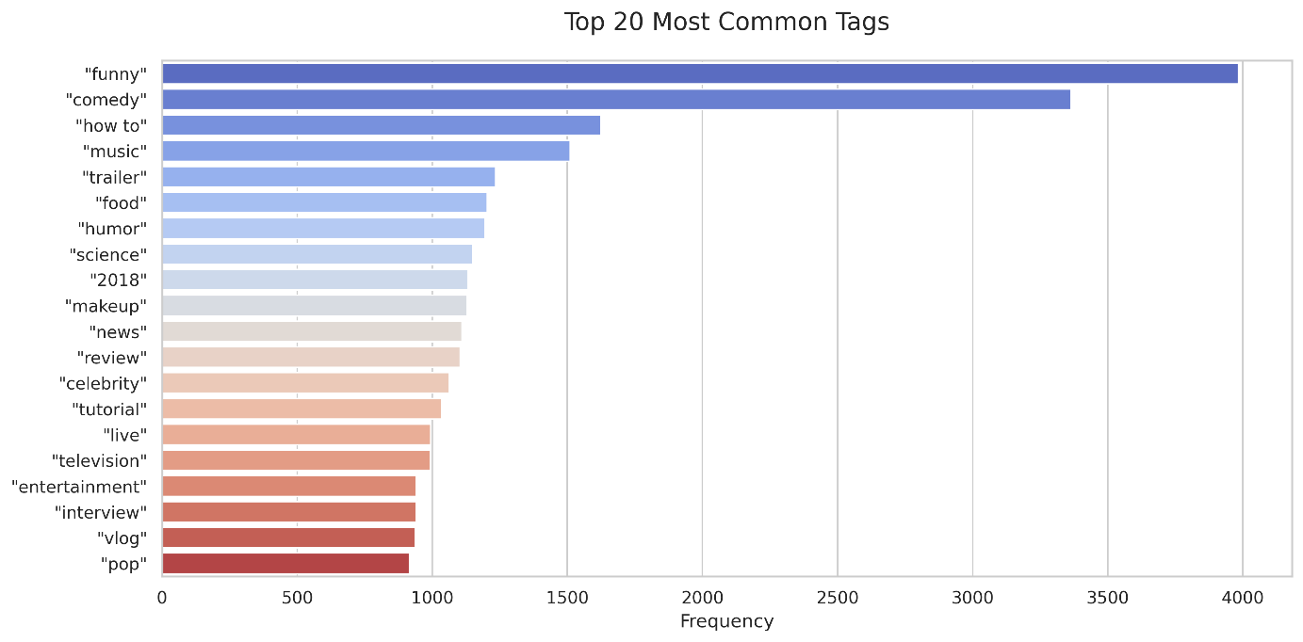
This dominance signals that humor remains a universally appealing hook, consistently driving discoverability and audience interest. Whether embedded in sketches, commentary, or even educational content, comedic framing appears to be a reliable ingredient in trending success.
Do Title and Description Lengths Matter? Absolutely.
Let's turn to the textual framing of videos—specifically, how the length of a title or description affects engagement.
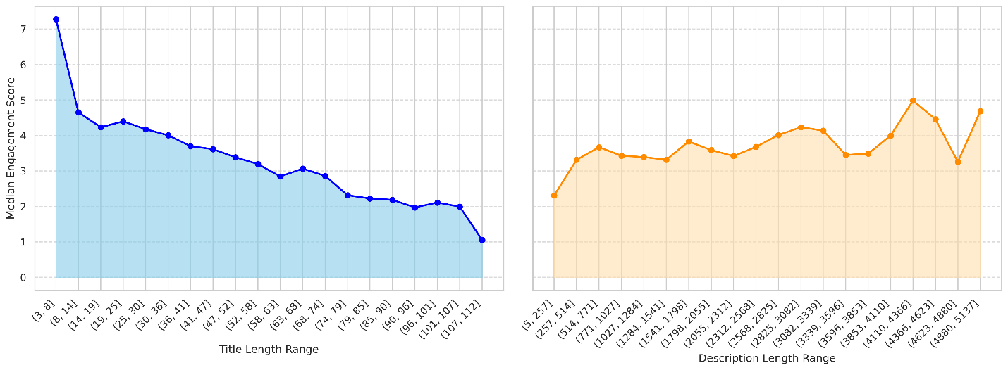
Longer titles correlate with lower median engagement scores. As title length increases, viewer interaction steadily declines. This suggests that audiences favor concise, attention-grabbing titles—ones that intrigue without overwhelming.
Description length, however, tells a more nuanced story. The lowest engagement scores cluster around short descriptions (5 to 257 characters), possibly signaling rushed or incomplete video metadata.
Surprisingly, the highest engagement scores peak at very long descriptions (4110 to 4366 characters), indicating that in-depth content summaries, links, and context may enhance viewer experience—though this effect is weak and inconsistent overall.
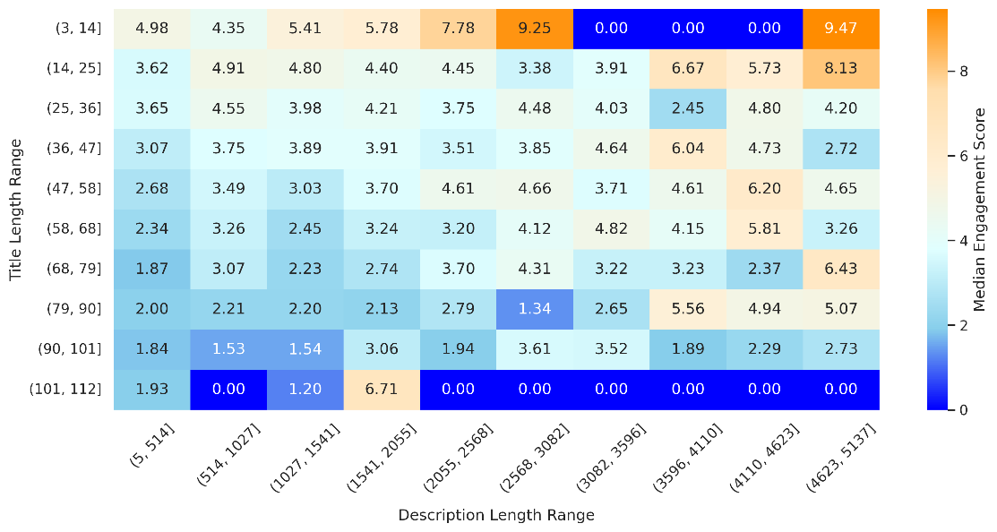
In short, while brevity is best for titles, a well-structured, content-rich description may provide additional value—especially for longer-form or informational content.
The Tag Sweet Spot: Not Too Few, Not Too Many
Tags help surface videos through search and recommendation algorithms, but their effectiveness depends on volume:
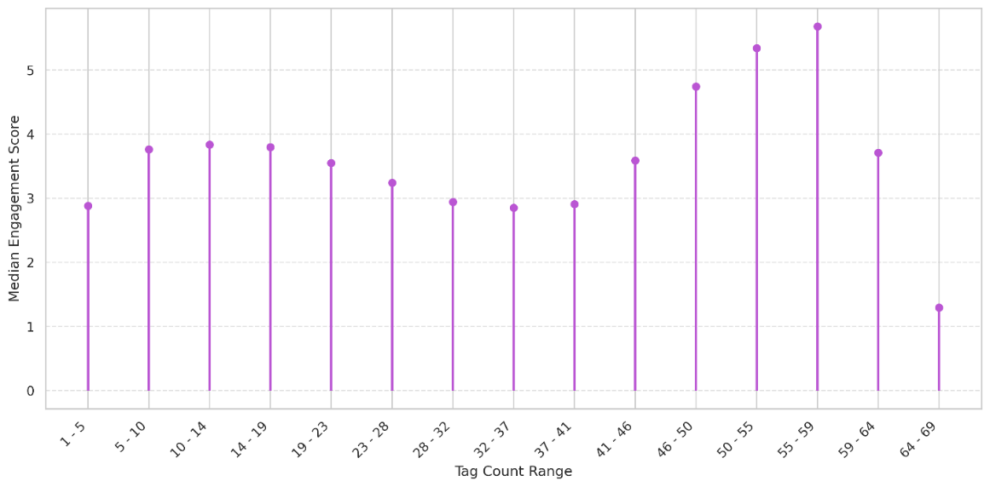
Engagement increases monotonically for tag counts between 37 and 59, suggesting that a moderately high number of relevant tags improves discoverability and viewer interest. Beyond this range, however, engagement starts to decline—perhaps due to dilution of relevance or perceived "spamminess". This defines a clear sweet spot: a rich but focused tagging strategy outperforms both minimalist and excessive approaches.
Insight:
"Metadata Is the First Impression—Make It Count"
From playful tags to punchy titles, metadata shapes the context in which viewers encounter a video. This analysis underscores the importance of being intentional:
- Lean into humor when possible—it's a common thread among top performers.

- Craft concise titles that promise value without clutter.

- Use descriptions strategically to enrich viewer experience, especially for complex content.

- Aim for 37–59 high-quality tags to boost discoverability without overstuffing.

In a landscape where thumbnails and metadata often decide whether a video gets clicked, these small optimizations can lead to outsized engagement wins.

3 Predicting Engagement: What the Data—and the Audience—Really Respond To
After training an XGBoost regression model to predict a video's engagement score based on a suite of features—ranging from time-based variables to metadata attributes. Category emerged as the single most predictive feature by a wide margin, eclipsing all others. the top predictors were:
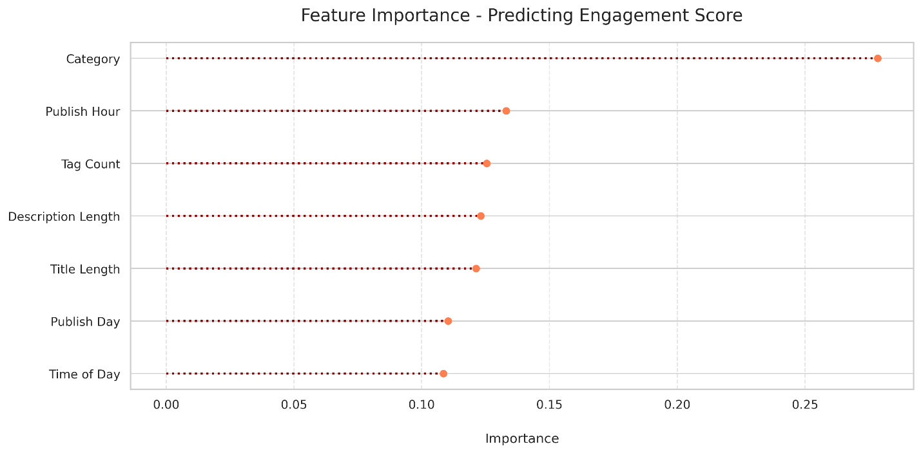
This confirms what earlier analysis hinted at: what a video is about (i.e., its category) matters far more than when it's posted or how it's framed. Audiences are selective, and their preferences lean toward certain themes—some of which naturally lend themselves to higher interaction.
Sentiment Matters: Positivity Wins
Next, let's investigate the emotional tone of video descriptions, by way of categorizing them into positive, neutral, and negative sentiment buckets using sentiment analysis.
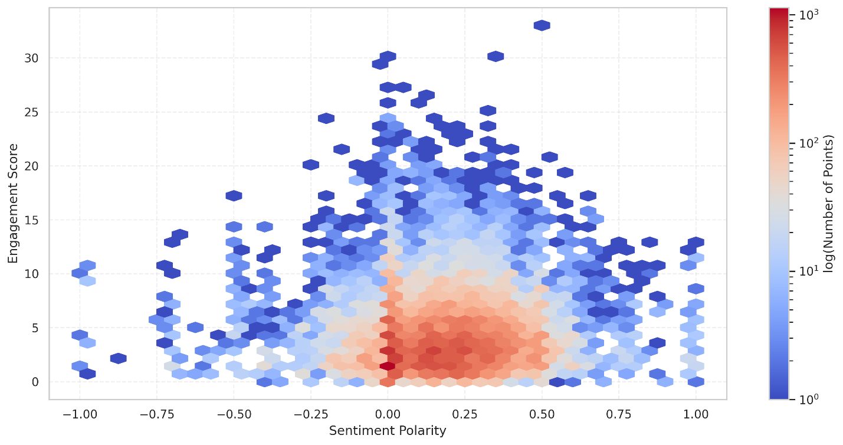
Kruskal-Wallis H test reveals a statistically significant difference in engagement scores across sentiment types. Upon closer examination, descriptions with positive sentiment consistently earned higher median engagement scores, while negative sentiment trailed behind. In a media ecosystem often driven by outrage and controversy, this insight is refreshing: optimism and enthusiasm resonate more deeply with audiences.
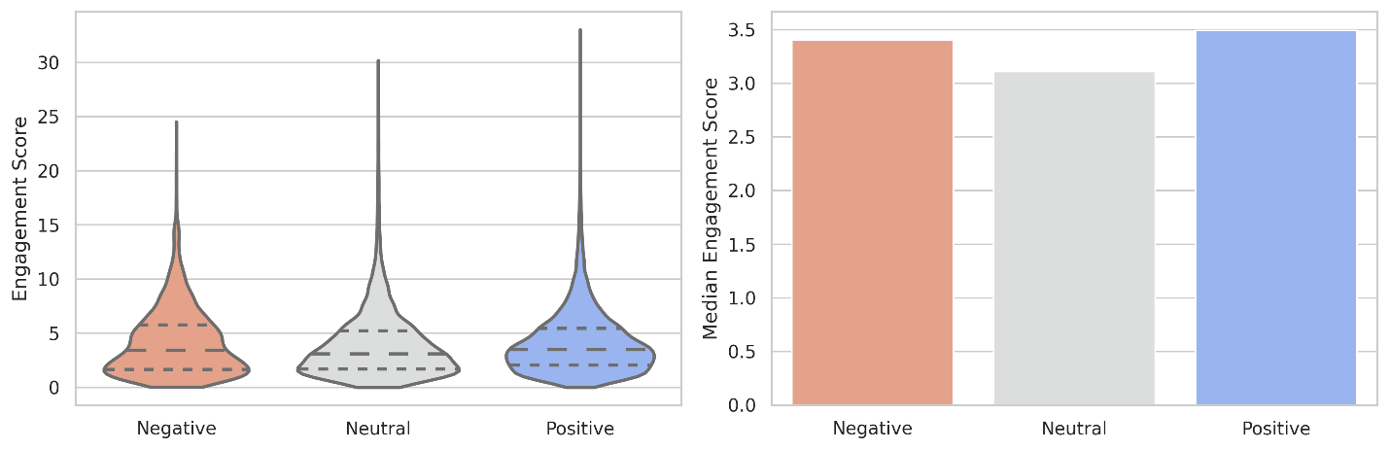

The Clickbait Conundrum: High Curiosity, Low Connection
Clickbait—the art of luring clicks through hyperbolic or misleading titles—is common in online content. But does it work?
To test this, clickbait titles were automatically identified based on trigger words (e.g., “shocking,” “you won’t believe,” “must see”) and a Mann-Whitney U test was performed on their engagement scores.
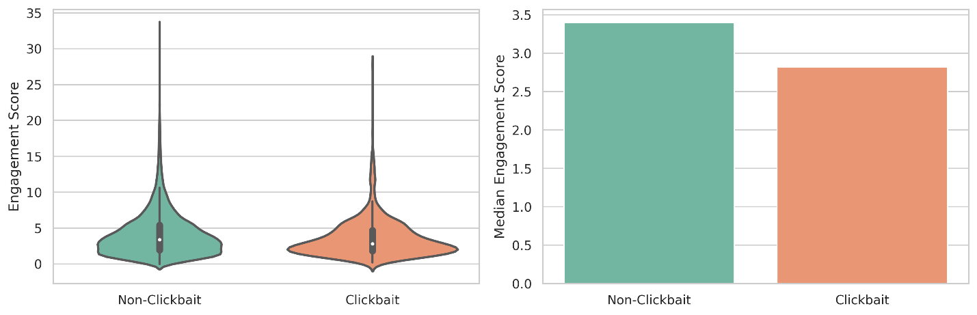
The results were clear: non-clickbait titles significantly outperformed clickbait ones in terms of median engagement score. While clickbait may boost impressions, it seems to undermine authentic viewer interaction—leading to lower likes, comments, and overall engagement. The next question is which categories leaned most on this tactic. The findings were interesting:
- Shows stood out, with ~20% of titles being click-baity—the highest among all categories.

- Travel & Events followed distantly, with under ~10%.

This suggests that entertainment-driven categories are more likely to chase attention, while others may rely more on content value.

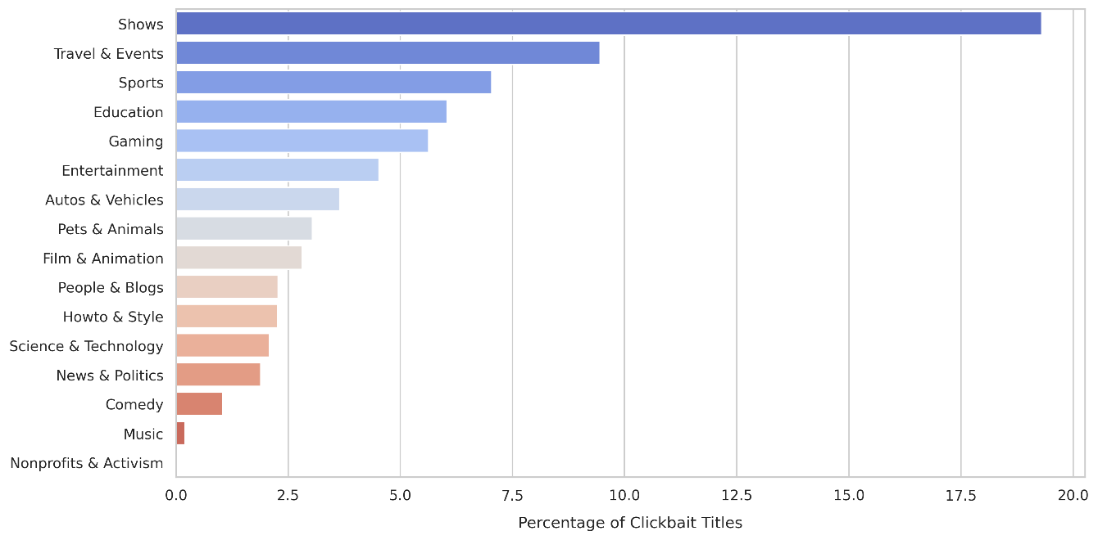
Insight:
" Know Your Audience, Respect Their Time"
From machine learning to sentiment to clickbait, the message is consistent: audiences engage with content that feels intentional, relevant, and authentic. The data shows that:

- Content category is the primary driver of engagement, with metadata playing a secondary—but still meaningful—role.

- Positive sentiment is more engaging than negativity or neutrality.

- Clickbait may win the click, but loses the conversation.

For creators, the roadmap is clear: deliver value, stay on-message, and trust that authenticity outperforms gimmicks in the long run.

4 Timing and Taste: Uncovering What Drives Trending and Engagement on YouTube
Does Publish Day Predict Trending Potential?
To understand whether a video's publish day impacts its likelihood of appearing on the trending list, a Chi-Squared goodness-of-fit test was applied to compare the observed distribution of trending videos by day of the week against an expected uniform distribution. The result indicated that there is a statistically significant association between the day of the week a video is published and its likelihood of trending.
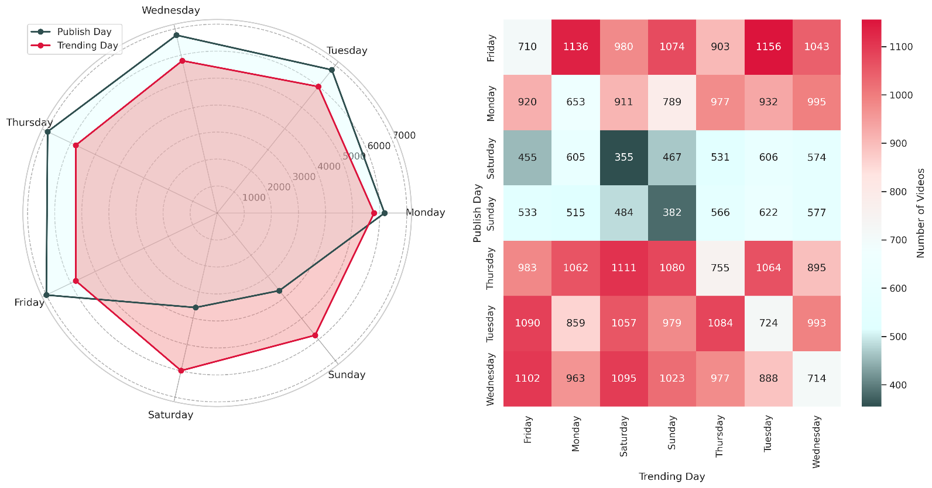
Delving into the data, a striking pattern is unveiled. Saturday and Sunday show a drastic dip in the number of trending videos, while weekday uploads are distributed relatively evenly. This insight suggests that creators aiming to land on the trending page should avoid weekend uploads and instead focus on weekday publishing, when audience engagement and platform visibility are more favorable.
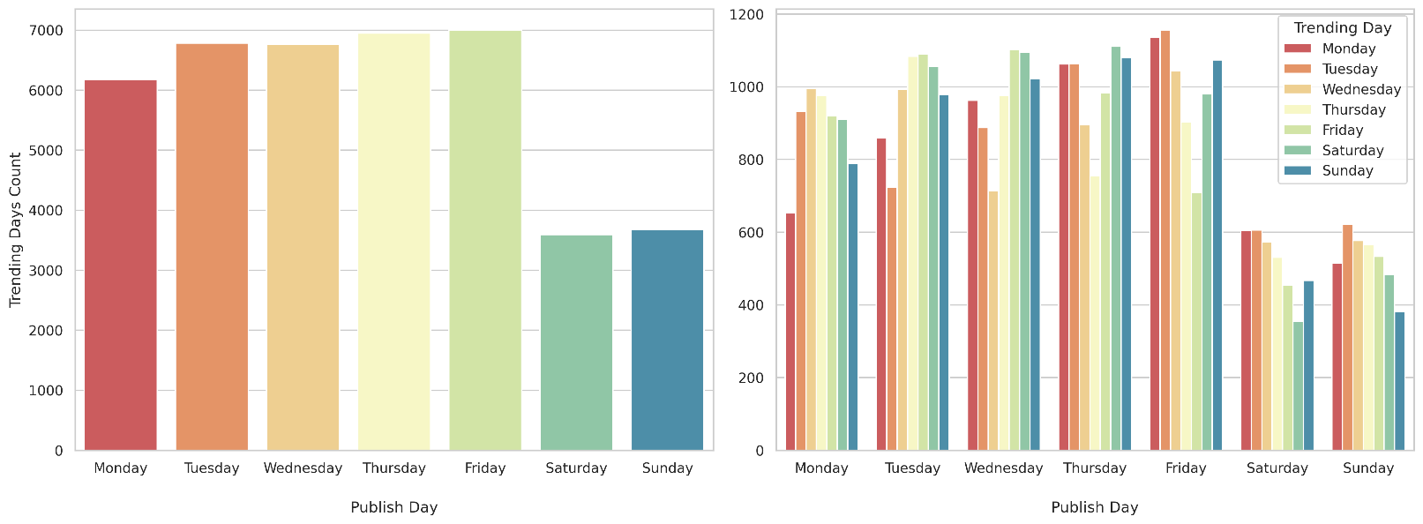
Do Video Categories Influence Viewer Engagement?
Beyond trending potential, it is interesting to explored how different video categories perform in terms of engagement, specifically the likes-to-views ratio—a normalized metric that reveals how compelling a video is relative to its reach. To this end, the Kruskal-Wallis H test was applied across all categories with sufficient sample size. Which confirmed that there is a statistically significant difference in likes/views ratios across video categories.
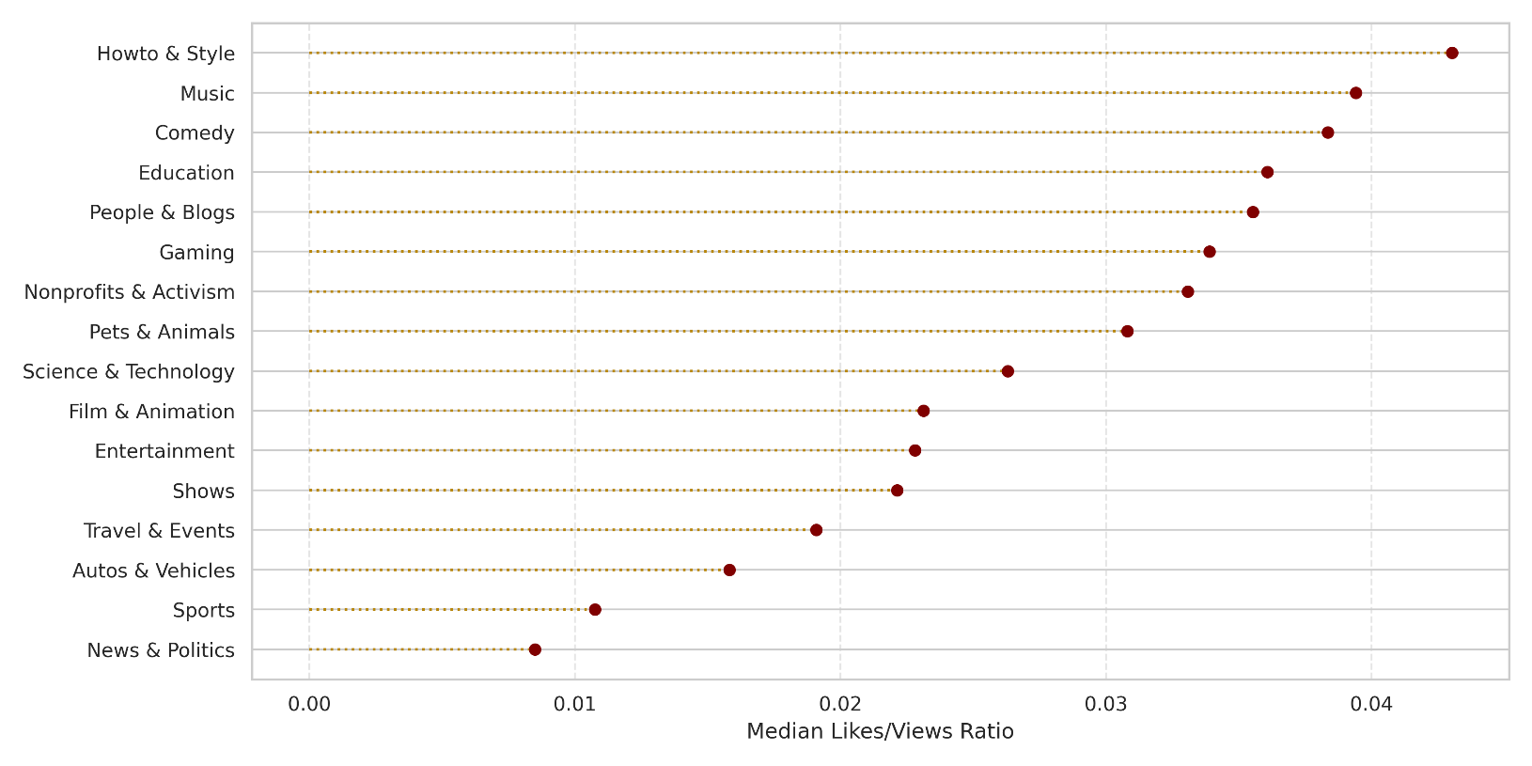
Unpacking the numbers reveals that content from the Howto & Style, Music, and Comedy categories garners the highest median likes/views ratios, indicating that these genres foster stronger viewer affinity per impression. In contrast, videos in Autos & Vehicles, Sports, and especially News & Politics show notably lower engagement, suggesting that while they may attract views, they don’t consistently translate to audience approval.
Insight:
" Timing and Content Matter More Than You Think."
This analysis highlights two foundational truths for creators:

- When you publish can influence whether you trend.

- What you publish shapes how deeply your audience engages.

By aligning content strategy with these insights—publishing during high-opportunity weekdays and focusing on high-engagement categories—creators can increase their chances of trending and building lasting viewer relationships.

5 Conclusion
The anatomy of a trending YouTube video is far more intricate than viral luck or flashy thumbnails—it’s a strategic interplay of content relevance, timing, audience psychology, and platform signals. These findings paint a clear picture: content category is king, with Music, Gaming, and How-To videos consistently outperforming others in both visibility and engagement. Timing matters, not just in terms of the day a video is published, but the exact hour—with evening uploads significantly outperforming morning or midnight ones. While audience sentiment plays a subtle but statistically significant role, the use of non-clickbait titles and concise, high-quality metadata (tags, titles, descriptions) further boost viewer interaction.
An interesting discovery was the paradox of visibility: controversial or polarizing content may attract attention, but it fails to foster meaningful engagement—underscoring the importance of audience trust and content tone. Predictive modeling reinforces these insights, confirming that content category, timing, and presentation elements are the most decisive factors in shaping a video’s engagement score.
Ultimately, this report offers more than just a snapshot of what’s trending—it provides a roadmap for how creators and strategists can align with platform dynamics and audience expectations. In a digital environment that rewards both creativity and clarity, the most successful content is not only attention-grabbing, but data-informed, context-aware, and crafted with intentionality.
6 Reference
- https://www.kaggle.com/datasets/datasnaek/youtube-new/

